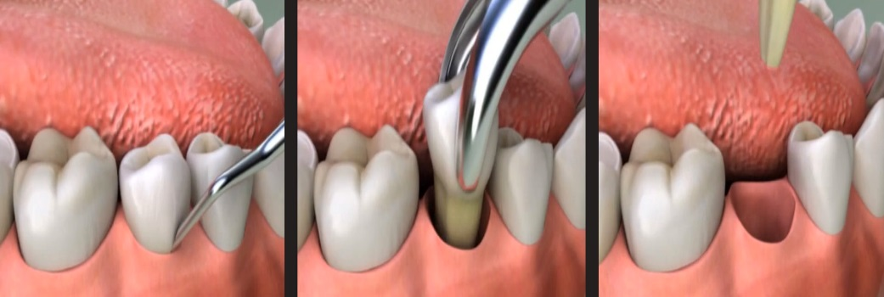

Extraction Consent & Care Instructions
Alternatives to removal have been explained to me (root canal therapy, crowns and periodontal surgery, etc.) and I authorize the Dentist to remove the following tooth/teeth______________________________. I understand removing teeth does not always remove all the infection, if present, and it may be necessary to have further treatment. I understand the risk involved in having teeth removed, some of which are pain, swelling, spread of infection, dry socket, loss of feeling in my teeth, lips, tongue, and surrounding tissue or fractured jaw. I understand I may need further treatment, the cost of which is my responsibility.

Ridge Preservation: Yes ______ No _____

Using: ________________________________

Patient Name: _____________________________

Patient Signature: __________________________

Date: ________________

Care Following Surgical Dental Procedures

Protection of blood clot: when you leave the office, maintain gentle pressure on the area with a moist gauze for about 30 minutes. If bleeding starts up again, it can be stopped by biting on a regular tea bag (do not use herbal), which has been moistened and wrapped in a piece of gauze. Keep steady, firm pressure on the area for 45 minutes. Repeat as often as needed.

Bleeding: it is normal to have oozing of blood from extraction site for up to two days. Remember a little bit of blood mixed with saliva will look like a great deal of blood. You are not having a bleeding problem unless large clots are being produced.

Do not rinse: or use mouthwash for at least 24 hours. It is recommended after 24 hours that you rinse with warm salt water (1/2 tsp. salt to 8oz water).

Discomfort: following dental surgery is normal. If medications have been prescribed, take as instructed.

Hygiene: it is important to keep your mouth clean during the healing process, so be sure to brush your teeth during the healing time. Brush carefully in all areas of your mouth except the surgical site, unless instructed to by the doctor or the assistant. A clean mouth heals faster.

Eating: adequate food and fluid intake following dental surgery is very important. Limit food to cool or cold items on the first day. If you find eating your regular diet is too difficult, you may supplement your diet with liquids such as Carnation Instant Breakfast.

Avoid: all strenuous activity, it can increase bleeding and swelling. Avoid any type of suction can disturb the blood clot, slow the healing process, or cause a dry socket (very painful). This means do not consume liquids through a straw and refrain from smoking until the clot is well established (3 days in most cases).

Sutures: if sutures are used, please remember to return for removal on the appointment date.

Control of swelling: gently apply ice packs to the outside of your cheek. Keep ice pack on as much as possible, to keep swelling to a minimum. If pain or swelling, and/or redness persist for more than 3-4 days, something may be wrong. Please contact our office. (620) 672-3612

Allergic reactions: if generalized rash or itching should occur, call our office immediately.

